How to reset your password for the NT Jobsite

Note for NT staff: As you’ll already have access to NT Jobs via your MYplace access you should use that link instead.

This guidance is for users who already have an account in NT Jobs but need help resetting their password. You’ll be asked periodically to update your password in order to apply for roles and view your application history etc.

It’s important that you do not Sign Up as this creates another account and only one active account must be assigned to a user at any one time to prevent issues with the account.

To avoid issues, please enter your information manually rather than using auto-fill technology.

Note: Your new password must be 15 characters or more. A good password should be easy to remember, hard to guess and must not include personal information or be similar to a previous password.

Follow these steps to reset your password:

- Click SIGN IN OR SIGN UP



- Ensure the SIGN IN tab is highlighted and click ‘Forgot your password?’

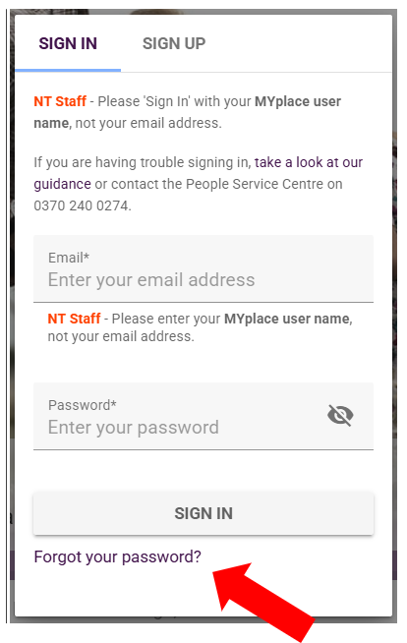

- If you are a candidate, enter your email address. If you are NT Staff, enter your MYplace User Name e.g. JOE.BLOGGS. Click Submit.

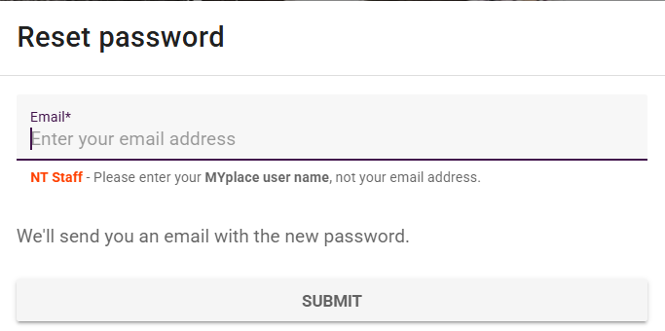

- Check your emails (Inbox, Other and Junk folders) for an email with the temporary password to use.

If you do not receive an email within 10 minutes, it may be because your account has been
locked due to a number of unsuccessful attempts to enter your password previously. Please
contact the People Service Centre on 0370 240 0274 if it has not arrived.

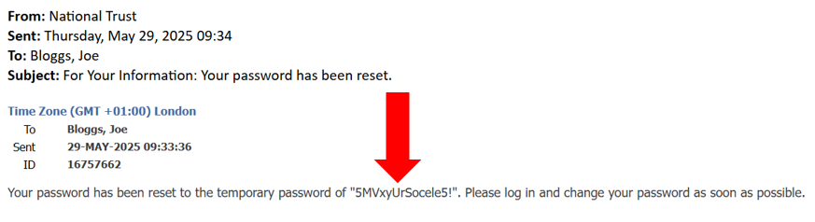

- Return to the login screen and enter your email address (or MYplace user name if NT Staff) and your temporary password. You can copy and paste this if it helps.

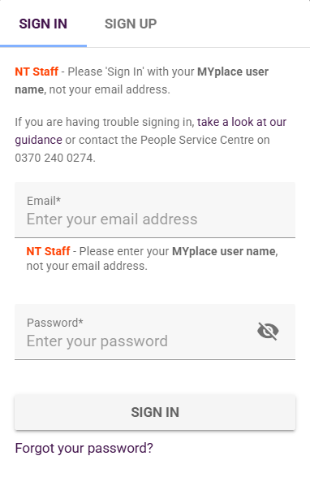

- You’ll be taken to a screen to change your password. Use the temporary password as your ‘Current Password’.

Your ‘New Password’ must be at least 15 characters.

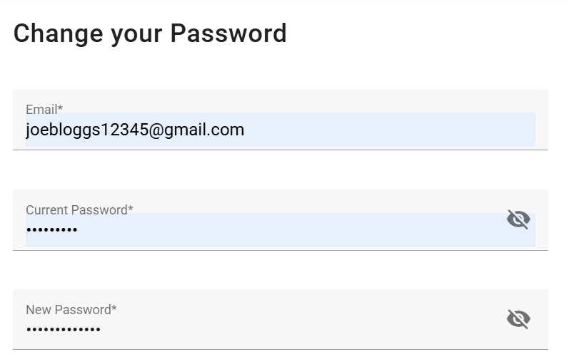

- Once entered successfully, you’ll be returned to the Sign In screen where you should now be able to log in.

Please contact the People Service Centre on 0370 240 0274 if after following this guidance
you are still experiencing issues resetting your password.

